Proposal for the
Buyer Plant Machine Trains

SETPOINT™ Machinery Protection Systems
And Condition Monitoring Software

Buyer Contact:
<BUYER_CONTACT_NAME>
<BUYER_CONTACT_TITLE>
<BUYER_COMPANY>
<BUYER_ADDRESS>
<BUYER_PHONE>
<BUYER_EMAIL>

Brüel & Kjær Vibro Contact:
<SALES_NAME>
<SALES_TITLE>
<SALES_PHONE>
<SALES_EMAIL>
www.bkvibro.com

Table of Contents

1. Executive Summary 3
2. Pricing 3
3. Product Scope of Supply 3
3.1 Parameter List 3
3.2 General Bill of Material 4
4. Service Scope of Work 5
4.1 Services Scope of Supply 5
4.2 Service Descriptions 5
4.1 Other Services Responsibilities 8
5. Product Descriptions 9
5.1 VC-8000 Machinery Protection System 9
5.2 MPS Freestanding Cabinet 12
5.3 MPS Weatherproof Housing 13
5.4 Sensors 14
5.5 SETPOINT Condition Monitoring Software 16
6. Proposal Terms 19
7. General Cabinet Delivery Schedule 20
8. Exceptions and Clarifications 20
9. Attachment List 21

Revision History
Date | Revision | Description
<REV_DATE> | <REV_NO> | <REV_DESC>

Executive Summary
Brüel & Kjær Vibro (Vendor) is pleased to offer this proposal to Buyer Name (Buyer) for the Machinery Protection System (MPS) and Condition Monitoring Software (CMS).
More information about the products can be found in Section 5.

Pricing
Scope of Supply Description | Price
<PRICE_SCOPE> | <TOTAL_PRICE>
Table 1

Product Scope of Supply

Parameter List
This proposal is based upon assumptions in Table 2.
Machine | Parameter Description | Parameter Quantity | UMM Monitors | VC-8000 MPS
<M1_NAME> | <M1_P1_DESC> | <M1_P1_QTY> | <M1_P1_UMM> | <M1_P1_MPS>
 | <M1_P2_DESC> | <M1_P2_QTY>
 | <M1_P3_DESC> | <M1_P3_QTY>
<M2_NAME> | <M2_P1_DESC> | <M2_P1_QTY> | <M2_P1_UMM> | <M2_P1_MPS>
 | <M2_P2_DESC> | <M2_P2_QTY>
 | <M2_P3_DESC> | <M2_P3_QTY>
Totals: |  | <TOT_QTY> | <TOT_UMM> | <TOT_MPS>
Table 2

General Bill of Material
Vendor will provide the following parts:
Group | Item | Description | Part Number | Quantity
MPS | <MPS_I1> | <MPS_DESC1> | <MPS_PN1> | <MPS_QTY1>
 | <MPS_I2> | <MPS_DESC2> | <MPS_PN2> | <MPS_QTY2>
 | <MPS_I3> | <MPS_DESC3> | <MPS_PN3> | <MPS_QTY3>
 | <MPS_I4> | <MPS_DESC4> | <MPS_PN4> | <MPS_QTY4>
CMS | <CMS_I1> | <CMS_DESC1> | <CMS_PN1> | <CMS_QTY1>
 | <CMS_I2> | <CMS_DESC2> | <CMS_PN2> | <CMS_QTY2>
Spares | <SPARES_I1> | <SPARES_DESC1> | <SPARES_PN1> | <SPARES_QTY1>
 | <SPARES_I2> | <SPARES_DESC2> | <SPARES_PN2> | <SPARES_QTY2>
 | <SPARES_I3> | <SPARES_DESC3> | <SPARES_PN3> | <SPARES_QTY3>
Table 3

Product Assumptions
Please note the responsibilities table for necessary OSI Soft PI licensing, hardware and software:
Buyer (or Others) | Vendor | Scope Description
 |  | Local PI Server Hardware
 |  | PI Server 2012 or later Software + PI Asset Frameworks Server License
 |  | PI Asset Frameworks Client License
 |  | PI Tags (Approximately 524 PI Tags will be consumed)
 |  | PI ProcessBook, PI DataLink, or PI Vision Licenses
 |  | PI System Access (PSA) for SETPOINT
 |  | SETPOINT-to-PI Adapter
Table 3

Service Scope of Work
The Vendor Services team has extensive experience delivering some of the largest ‘green field’ and retrofit conditioning monitoring projects in the world. We routinely deliver comprehensive Project Management for the entire project to include management of all pre-mobilization deliverables such as electrical drawing package, coordination of rack configuration details, setting up communication MODBUS data interface, and all aspects of an integrated Factory Acceptance Test for the required components. Whether working with EPC’s, System Integrators or end users, we have decades of experience to ensure successful project deployments and provide years of value-added service for condition monitoring systems.

Services Scope of Supply
Vendor will provide the following services:
Group | Item | Description | Quantity
Services | <SVC_ITEM1> | <SVC_DESC1> | <SVC_QTY1>
 | <SVC_ITEM2> | <SVC_DESC2> | <SVC_QTY2>
Table 4

Service Descriptions

In-House Electrical Designs
In-House electrical designs to include, System Overview, Machine Train Diagram, transducer interconnect wiring diagrams and MPS rack layout. These designs will be provided to the Buyer for one review cycle.

On-Site Kick-Off Meeting
A senior project manager with extensive field experience will schedule and conduct a detailed project kick-off meeting. The meeting will include a site walk-down, discussion of preliminary designs, and discuss project schedule.

Rack Configuration
Vendor will configure the MPS per Buyer provided settings. The configuration details are to include, but not limited to: Channel Tags, Full Scale Ranges, Alarm levels, & Alarm Relay Logics.

PI ProcessBook Screen
Vendor will set up CMS on the PI server and configure one ProcessBook display screen per machine.

Remote Optimization
Vendor will connect to the CMS server remotely within 4 weeks after machine startup to optimize, or fine-tune, the system. This includes reviewing the configuration settings of the MPS system(s) and adjusting as needed. If remote connection cannot be provided, then the optimization can be completed remotely using data extracts provided by Buyer.

System Check-out and Loop Checks
Vendor will perform electrical loop checks from the machine’s transducer system to the MPS Rack and to the plant’s DCS/PLC system and any annunciations or trips (if applicable). The check-out procedure between MPS rack and DCS will involve simulating signal at MPS rack using a function generator for vibration and phase trigger, and DC power supply for thrust position. Check channel’s mid-scale and full scale (if analog outputs are used) and/or simulate below and above each HI and HI-HI alarm to test relay contacts. The check-out procedure between field sensors and MPS Rack will be a loop check from field wiring in the field to MPS Rack by connect/disconnect (OK/Not OK) each individual channel to ensure the correct probe goes back to the correct monitor channel.

Existing Probe Checkout
Remove externally* mounted proximity probes and perform probe verification curves (gap vs. distance) to ensure that the transducer system is performing to sensor specifications. Once the transducers have been determined to be within specifications, they will be reinstalled and adjusted to achieve proper gap voltages and torque settings.
For applications that monitor thrust, once the thrust transducers have been verified and reinstalled, the probe’s calculated accuracy will be crosschecked between the machine’s mechanical float and the probe’s indicated electrical float. It is the Buyer’s responsibility to reposition the machine’s rotor for this mechanical test.
Note: if the proximity probes are internally mounted, it is the Buyer’s responsibility to provide access for the verification curves. This proposal does not include replacement of any transducers, cables, drivers, junction boxes, electrical materials that are found in an un-acceptable condition.

Transducer Installation
Vendor will install the new transducers on the machine train. This will include proper gapping, torque and checkout. All electrical material and labor will be provided by Others. This includes but is not limited to: demolition and disposal of existing transducers, new mounting hardware, any machine modifications, routing of the extension cables through existing conduit, mounting of drivers in existing junction boxes, landing cables and field wiring.

Informal 4-Hour MPS Training
Vendor will provide an informal four (4) hour training session for operators and maintenance personnel on the VC-8000 MPS system. This training will be done concurrently to the installation and configuration. The training will cover how to make rack configuration changes and how to navigate the rack display, as applicable.

Informal 4-hour CMS Training
Vendor will provide an informal four (4) hour training session for rotating and reliability personnel on the SETPOINTTM CMS system. The training will cover how to navigate through the CMS Display client, and export CMS data for data sharing.

Informal 8-Hour SETPOINT Training
Vendor will provide an informal eight (8) hour training session for operators and maintenance personnel on the VC-8000 MPS & SETPOINT CMS system. This training will be done concurrently to the installation and configuration. The training will cover the following:
- Making rack configuration changes
- Navigating the rack display, as applicable
- Navigating through the CMS Display client
- Exporting CMS data for data sharing

System Commissioning Report
A field services commissioning report will be provided after the project which may include the following, as applicable: probe curves, rack configuration details, list of Modbus registers, electrical loop drawings, list of recommended spares, and photos of probes and system installed.

Formal 3-Day MDS Training
Vendor training seminars are designed to give students the knowledge and skills required to perform more effectively. The seminar content and design is based on over 30 years of MD and product training experience and can be customized to meet specific needs. All seminars are structured for:
- Small student-to-instructor ratio for maximum interaction (8-12 per instructor)
- Extensive hands-on practice using full-featured lab equipment

Installation Supervision of Sub-Contractors
An experienced Field Engineer will be assigned to supervise site activities, including subcontracted millwrights, machinists and electricians (as required). Our engineers have decades of experience in delivering complex systems during hectic, compressed timeframes such as outages and turnarounds.

On-Site Mechanical Designs for New Probe Installations
AutoCAD drawings will be submitted for review and approval prior to any modification to Buyer machinery required for probe installation or cable penetrations. Final “as-built” drawings will then be provided after installation.

Subcontract Labor
Craft labor provided on cost-plus 15% basis. Intent of this offering is to maintain a single point of contact for the overall quality of the installation. Vendor will bid work from several Buyer preferred subcontractors for competitive pricing prior to contract work.
Electrical Installation
The electrical installation will include the materials and labor to complete the following scope, per Vendor electrical designs and direction:
    - Mounting junction boxes along the machine to house the probe drivers and any termination strips.
    - Installation of conduit between the transducer housings and junction boxes, located along the machine.
    - Routing and installing conduit and field wiring between the junction boxes and the control room cabinet where the MPS will be installed. If cable trays are existing and available, these will be utilized to reduce conduit costs. Vendor assumes the distance between the machine and the control room cabinet is 30 meters.
    - (De-termination of existing field wiring and other cabling from existing rack.)
    - (Removal of Existing 3300 rack.)
    - (Manufacture and installation of blank plate(s) to cover any old monitoring rack vacancies in the panel.)
    - Installation of the MPS, power supply and display.
    - Termination the (existing) field wiring and other cabling to the new MPS.
Mechanical Installation
The mechanical installation will include the materials and labor to complete the following scope, per Vendor mechanical designs and direction:
    - Drilling and tapping the machine casing for installation of supplied transducers and transducer housings.
    - Machining any mounting brackets required for this project.

Other Services Responsibilities
This proposal is based upon the following responsibility table.
Item | Description | N/A | Vendor | Buyer
 | Receiving, off-loading and storage of Vendor provided parts
 | Machine disassembly/assembly
 | Removal of existing probes from machine for testing
 | Demolition of existing equipment for retrofit
 | Disposal of existing demolished equipment
 | Provide Proximity, Accelerometer and Velocity sensors and sensor accessories
 | Provide RTD sensors, junction boxes, field wiring, tagging and, if necessary, cable trays to MPS enclosure.
 | Installation of sensors, sensor accessories, sensor mounting hardware, conduit, junction boxes, extension cables, drivers, field wiring, tagging, cable trays to MPS location
 | Sensor gap testing
 | Provide MPS enclosure with MPS and wiring pre-assembled per approved design, FAT tested.
 | Installation of Vendor supplied MPS enclosure
 | Retrofit of existing MPS enclosure to accommodate the new MPS
 | MPS installation and connection of field wiring, cables, power and ground per Vendor electrical design package and prior to Vendor arrival on-site.
 | Commissioning and informal training for MPS and CMS.
 | Provide and install Ethernet cables, Fiber Optic cables and Ethernet switches as required for connection to the new or existing PI Server.
 | Personal safety equipment; such as hard hats, eye protection, ear protection, safety boots, and Flame Retardant clothing
 | Other mandatory personal safety requirement specific to the plant; including but not limited to, face shields, acid suits and fall protection
 | Supply applicable plant electrical / mechanical drawings as needed to perform work scope
 | Supply all provisions necessary for the identification, removal, handling and disposal of hazardous materials including, but not limited to, asbestos or lead oxide paint prior to Vendor arrival to site
 | Supply a suitable workspace for Vendor with power and printer access
 | Provide sanitary, wash and change facilities
 | Supply lock out and tag out as needed for performance of work scope
 | Supply first aid services/provisions for medical care and fire protection/suppression equipment and services to meet the requirement of OSHA CFR 29 Part 1926 or local code
 | Supply applicable on-site safety training and orientation as needed to work on-site
 | Supply badge access and work permit to the plant for Vendor personnel
 | Permits, licenses and governmental/public utility charges and inspection fees
Table 5

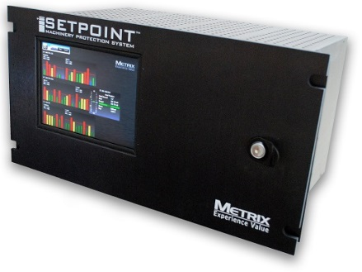
Product Descriptions

VC-8000 Machinery Protection System
The VC-8000 System is a rack-based continuous machinery monitoring platform designed to fully comply with American Petroleum Institute Standard 670 for machinery protection systems. Up to 56 vibration/position/ speed channels or 84 temperature channels can be monitored and displayed in a single 19” rack. The system measures and alarms using four basic module types, simplifying spare parts requirements.
The Machinery Protection System consists of the following components:

Rack Chassis
The rack chassis holds all modules and is available in the following sizes: full (16-slot), half (8-slot), and quarter (4-slot). All rack sizes can be mounted in a rectangular panel cutout or bulkhead mounted using the included brackets. The 16-slot size can also be mounted on 19” EIA rails. 16-slot and 8-slot racks can be ordered with or without a lockable door to protect all wiring and installed modules; the door is available with or without an optional 8.4” color touchscreen display. Slot 1 in each rack is reserved for the Rack Connection Module (RCM). Slots 2 and 3 may be used for System Access Modules (strongly recommended) or UMM/TMM modules. Slots 4 and up can be used for UMM/TMM modules in any mix.

Rack Connection Module (RCM)
The Rack Connection Module (RCM) provides connections from the rack to an external power source and accepts 24Vdc power as standard. It also provides connections to the rack’s OK relay and discrete control functions such as Trip Multiply, Inhibit, Reset, and Special Alarm Inhibit. When 24 Vdc power is not readily available, a variety of external power supplies are offered by Vendor to convert 110/220 VAC, 90-250 VDC, and even selected 3-phase voltages to 24VDC.
For connecting the MPS to external systems, such as a multi-channel data recorder or a Bently Nevada communications processor, buffered transducer outputs for up to 56 channels are available at a special connector pair on the RCM’s front panel. The buffered signals from each Universal Monitoring Module are also available via an RJ45 connector on the UMM faceplate, and via 3 programmable BNC connectors on the door when the rack is supplied with an optional touchscreen display.

System Access Module (SAM)
The System Access Module (SAM) provides robust, comprehensive communications capabilities between the MPS and connected systems/devices such as plant and machinery control systems, configuration software, condition monitoring software, and an optional touchscreen display. Because the SAM is not in the critical machinery protection path, it enhances basic rack functionality without impeding machinery protection, even in the unlikely event of a SAM failure. Each SAM occupies a single slot in a rack and uses 24 Vdc instrument power as supplied by the Rack Connection Module (RCM). At least one SAM should reside in each MPS. Dual SAMs are also supported when MODBUS redundancy is required. See Figure 1: Illustration showing eSAM’s Functionalities on Proposal Page 10.
Functionality | bSAM | eSAM
MODBUS® TCP/IP communication integration with plant control systems | X | X
Backplane network communications for other installed modules | X | X
Detect/Annunciate (via System OK relay) when any monitoring module losses power and/or ability to communicate | X | X
Clock synchronization using Network Time Protocol (NTP) | X | X
Support for display |  | X
Connectivity to SETPOINT CMS software |  | X
Storage of i-factor™ data for later analysis by CMS display software/MDS |  | X
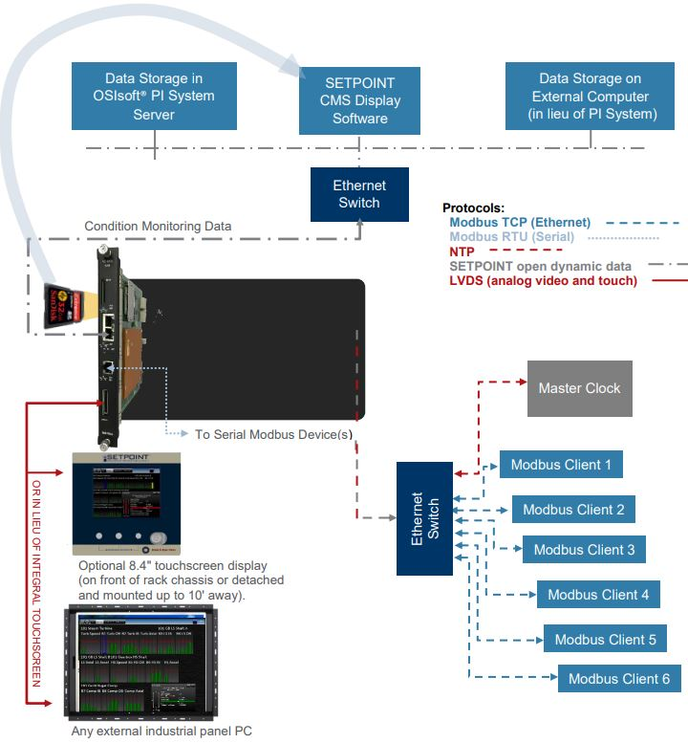
Figure 1: Illustration showing eSAM’s Functionalities

Universal Monitoring Module (UMM)
The Universal Monitoring Module (UMM) provides four channels of machinery monitoring. Each channel is individually configurable for nearly 30 different types of vibration, position, and speed measurements on rotating and reciprocating machinery.
The UMM occupies a single slot in the MPS and uses 24 Vdc instrument power as supplied by the Rack Connection Module (RCM). Each UMM provides all necessary transducer power, signal conditioning, alarm comparison, and relay logic functions needed to provide four channels of continuous machinery monitoring and shutdown protection. It complies with the requirements of American Petroleum Institute Standard 670 for monitoring systems and is completely configurable using configuration software.
When ordered with optional condition monitoring capabilities, the module streams high-speed static and dynamic (i.e., waveform) data to the rack’s System Access Module (SAM) where it is available to software such as SETPOINT CMS.

Temperature Monitoring Module (TMM)
The Temperature Monitoring Module (TMM) is a fully self-contained 6-channel temperature / process-variable monitor with its own power regulation and on-board alarm relays. A TMM’s relays can be programmed to use alarms local to the TMM, and/or from other monitoring modules in the rack. TMMs accept inputs from RTDs, thermocouples, and 4-20mA process variable transmitters in any combination. The module can be configured for a variety of measurements including: Temperature, group average temperature (from user-configured groups), differential temperature (between 2 temperatures or between temperature and group, process variables).
The list of supported measurements is constantly expanding and modules already in the field can be upgraded in-situ using the latest version of TMM firmware.

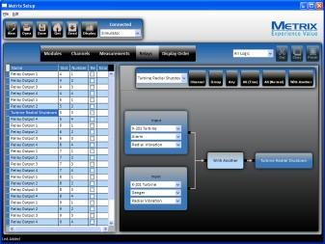
MPS Configuration Software
MPS Setup and Maintenance Software is used to configure the VC-8000 MPS and to perform maintenance activities such as firmware upgrades, channel bypass, alarm set point adjustments, and others. The software can also emulate the optional front panel touchscreen display. It is designed to run on compatible Microsoft® Windows® operating systems and connects to the rack using a supplied USB cable.

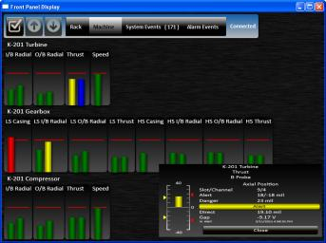
Integral Backlit Touchscreen Display
Both half- and full-size racks can be ordered with an optional 8.4” color touchscreen display. The display mounts on the rack’s lockable faceplate and provides all rack statuses and channel values on a single screen. It also allows the user to access detailed channel data, the system events list, and the system alarm list. The display fully complies with API 670 requirements.

Remote Display Panel
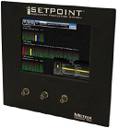
The RDP is a rack faceplate with touchscreen and programmable BNC connectors and provides all rack statuses and channel values on a single screen. It allows the display to be mounted up to 10’ away from the rack chassis. It also allows the user to access detailed channel data, the system events list, and the system alarm list. The display fully complies with API 670 requirements.

External Power Supply (EPS)
The MPS uses 24Vdc instrument power, commonly available at many sites. In these instances, a separate power supply is not required. However, when rack power will be supplied using other voltages, such as 110/220 Vac or 90-250 Vdc, we offer a variety of high-quality external power supplies that can be DIN-rail mounted wherever convenient. All of these supplies are ATEX approved for use in hazardous areas and engineered to fully meet the rack’s power requirements even at elevated operating temperatures of up to 65C.

MPS Freestanding Cabinet
The MPS will be provided pre-installed in a Cabinet/Enclosure. The Cabinet will be custom ordered and provided with the following features:

NEMA 12 Hoffman Cabinet
- Size: 84” x 36” x 18” (HxWxD)
- Material/Color: 12-gauge steel, ANSI 61 Gray
- Solid door, single access
- Signal wires from the units are to be terminated directly at the UMM and TMM within the MPS
- Four removable eye-bolt lifting lugs
- Duplex power outlet
- Fluorescent lamp

NEMA 12 Rittal Cabinet
- Size: 2100H x 800W x 800D, mm with 100mm base plinth
- Material/color: carbon steel, RAL 7032 Pebble Gray
- Solid door, single access
- Signal wires from the units are to be terminated at standard modular field termination blocks
- Four removable eye-bolt lifting lugs
- Duplex power outlet
- Fluorescent lamp

NEMA 12 Server Cabinet:
- Size: 2100H x 800W x 1000D, mm with 100mm base plinth
- Material/color: carbon steel, RAL 7032 Pebble Gray
- Installed:
  - One (1) rack-mount CMS/PI server
  - Pull-out, flip-open, rack-mount keyboard, mouse and monitor
  - Ethernet switch
  - Four removable eye-bolt lifting lugs
  - Duplex power outlet
  - Fluorescent lamp

Cabinet Documentation:
- Cabinet Assembly Drawing
- Dimensional Outline Drawings
- Wiring Termination Drawings

MPS Weatherproof Housing
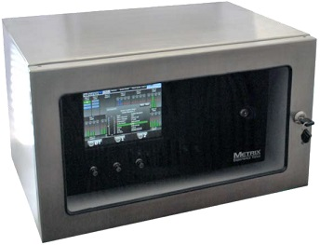
Weatherproof housings provide robust protection from the elements for the VC-8000 MPS. The housings have been specifically engineered to fit the dimensions of MPS and power supplies while providing sufficient clearance for heat dissipation and routing of wiring bundles.
Please note that the MPS, DIN Rail(s) and/or Power Supplies, do not come factory mounted inside WP Housing – some assembly is required.

Enclosures may be ordered with several options:
  - NEMA 4-12 / IP66 rating Powder-coated mild steel construction for water- and dust-tight protection.
  - NEMA 4X / IP66 rating Type 304 stainless steel construction for corrosion resistance in addition to water-tight and dust-tight protection.
  - With or without viewing window Enclosure door can be ordered as solid metal or with a polycarbonate viewing window.
- With or without conduit hubs
- Door-only versions When mounting the rack in a panel cutout, a door kit with polycarbonate viewing window is available to seal and protect the front of the rack and its optional touchscreen display.

Sensors

Displacement Sensor System – Series ds821/ds822
Sensors are the fingertips of any vibration measurement installation. Only high-quality sensors ensure that measurements are taken reliably and provide the necessary signal input for accurately monitoring the machine’s condition. We from Brüel & Kjær Vibro develop our sensors to the highest standards and in close cooperation with our Buyers to meet their demanding requirements. Our wide range of sensors has now been extended by the 2 mm measuring range family members of the non-contacting eddy-current displacement sensor (ECDS) systems:
- Series ds821 - Suitable for standard applications
- Series ds822 - For use in hazardous environments (ATEX, IECEx, EAC Ex, UL HazLoc)
Both series are now available in 4 mm and 2 mm measuring ranges and are designed for monitoring rotating and reciprocating machines with journal bearings in a wide range of industrial applications:
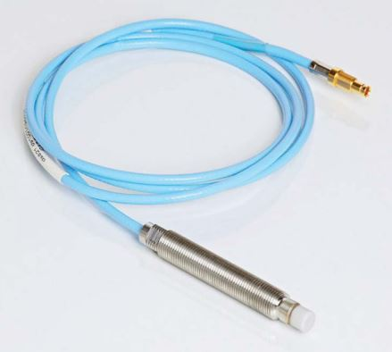
- Vibration (radial and axial vibration and displacement)
- Reference (phase reference and speed measurement)
- Position (e.g. axial shaft position, rod-drop/ rod position)
Some of the system's outstanding features:
- Auto selection of system length: The same ECDS oscillating driver unit can be used for both 5 m and 10 m cable lengths; this minimizes inventory costs and simplifies installation
- Push-pull self-latching connectors for secure, fast and easy installation on site; wrong assembly is avoided
- Very good EMC behavior
- Excellent temperature stability
- Ceramic probe cap for use in harsh surroundings
- Solder tip design for 2 mm measuring
- High reliability, even in harsh environments
- Compliance to API 670

Velocity Sensors
Range of Applications
The velocity sensors of Brüel & Kjær Vibro measure mechanical vibrations in the frequency range 1 Hz to 2,000 Hz. Their high level of reliability has been proven by long-term installations in industry.
Velocity sensors are used for the measurement of the
- Absolute casing vibrations
- Absolute bearing vibrations in machines.
Coordinated Solutions
The resonant frequencies of the velocity sensors are at 8 Hz or 15 Hz depending upon their different constructional features. Through electronic linearization of the respective frequency range it is possible to also measure vibrations that lie well below these resonant frequencies with high accuracy. The measuring and monitoring instruments of Brüel & Kjær Vibro operate with linearization circuits which are exactly tuned to the characteristics of our velocity sensors.
The Essential Benefits
- Selection of the adequate velocity sensor for the application from a variety of different constructional types for
  - High temperatures
  - Explosive and hazardous areas and
  - Underwater applications
- High suitability for industrial use thanks to the stainless steel casing:
  - Oil, water and dust-tight
  - Low sensitivity to disturbing factors
  - Suitable for use in a chemically aggressive environment and
  - Low sensitivity to external magnetic fields through special construction
- Simple mounting due to central threaded bore as well as the technically suitable installation accessories, cable and protective conduit
- Easy connection to the measuring instruments because
  - The active velocity sensor does not require a power supply and
  - Delivers a high output voltage at a low internal resistance.

SETPOINT Condition Monitoring Software

CMS Implementation
Capabilities | CMS_{HD} | CMS_{XC} | CMS_{PI}
Online Collection |  | • | •
Offline Collection | •
Events | • | • | •
Network Required |  | • | •
Server Hardware Required |  | • | •
PI Server Software Required |  |  | •
PI Asset Framework (AF) Server Software Required |  |  | •
i-Factor | • | • | •
Business Network Access |  | • | •
Analytics |  |  | •
Buffering |  |  | •
Backfilling |  |  | •
Scaling (supports > 150 Channels) |  |  | •
400+ Interfaces |  |  | •
Web Server |  |  | •
Uni-Directional Protocol |  |  | •
Database Replication |  |  | •
Process Data |  |  | •
Notifications |  |  | •
Bearing Database |  |  | •
Decision Support |  |  | •
Performance Monitoring |  |  | •
SETPOINT CMS Condition Monitoring Software provides a powerful, flexible, and comprehensive solution for collection, storage, and visualization of vibration and condition data from VC-8000 SETPOINT® Machinery Protection System (MPS) racks, allowing trending, diagnostics, and predictive maintenance of monitored machinery. The software can be implemented in three different configurations: CMS_{PI} (PI System), CMS_{XC} (eXternal Computer), and CMS_{HD} (Hard Drive).
CMS_{PI} (PI System)

This implementation streams data continuously from all VC-8000 racks into a connected PI Server infrastructure. It consumes on average 12-15 PI tags per connected vibration transducer (refer to manual S1176125). Customers can use their existing PI ecosystem, or for those without PI, a stand-alone PI server can be deployed as a self-contained condition monitoring solution. It provides the most functionality (see Tables 1 and 2) of the three possible configurations by offering full integration with process data, integrated aero/thermal performance monitoring, integrated decision support functionality, nested machine train diagrams and nearly unlimited visualization capabilities via PI Vision, and all of the power of the OSIsoft PI System and its ecosystem of complementary technologies.
CMS_{XC} (eXternal Computer)

This implementation streams data continuously from all VC-8000 racks, but into a simple fileserver rather and a PI System server. It is designed for customers that do not require a true database, integration with process data, or integration with other systems and merely want to store CMS data as files for later retrieval and viewing.
CMS_{HD} (Hard Drive)

This implementation is used when a network is not available between VC-8000 racks and a server, and the embedded flight recorder in each VC-8000 rack will be used instead. The flight recorder is a solid-state hard drive local to each VC-8000 rack that can store anywhere from 1 – 10 months of data. The data is identical to that which would be streamed to an external server, but remains in the VC-8000 rack until manually retrieved via removable SDHC cad media, or by connecting a laptop to the rack’s Ethernet CMS port and transferring the data.

Visualization Options
Capabilities | PI Vision | PI Process-Book | CMS Display
Multivariable Trends | • | • | •
Alarm Statuses / Lists | • | • | •
Tabular Data | • | • | •
Plant / Enterprise Diagrams | • | •
Machine Train Diagrams | • | •
X vs. Y | • | •
Acceptance Region |  |  | •
Polar |  |  | •
Bode |  |  | •
Spectrum |  |  | •
APHT | • | • | •
Orbits |  |  | •
Timebase |  |  | •
Shaft Centerline |  |  | •
Waterfall |  |  | •
Cascade |  |  | •
Compressor Map |  |  | •
Rod Position |  |  | •
Displaced Volume |  |  | •
Crank Angle |  |  | •
Air Gap |  |  | •
Plot Overlay Support | • | • | •
Point Selection / Navigation | • | • | •
View via Web Browser | •
Report Generation |  |  | •
Export to Microsoft Excel, | • | • | •
Export to .cms File Format |  |  | •
PI Vision is used only with CMSPI. It is a web server from OSIsoft® used in thousands of installations worldwide. It connects data sources (PI Servers) to visualization clients (web browsers) and provides a rich suite of tools for visualizing nonwaveform data. When used with SETPOINT® CMSPI, it serves as the platform for basic system navigation, machine train diagrams, machinery health monitor, asset hierarchy diagrams, alarm lists, statuses, and static data trends. When the user needs to view waveform data associated with one or more points, the CMS Display client is launched from within PI Vision web pages to bring up appropriate plots for the selected point(s).
PI ProcessBook is an alternative to PI Vision and is used only with CMSPI. It serves the same purpose as PI Vision, but is an older visualization client. While it does not support all of the features of PI Vision, it is adequate for many users and is an appropriate choice for users with a large installed base of PI ProcessBook across their enterprise who are not yet ready to upgrade to PI Vision. It is not a web-based product and the client software on each user’s desktop is thus a licensed application, not merely a web browser.
CMS Display is used with all three configurations of CMS (CMSPI, CMSXC, and CMSHD). It is a free download available at www.setpoint.bkvibro.com. When used with CMSPI, PI Vision or PI ProcessBook serves as the primary visualization environment where the user frequently builds “dashboards” with trends and statuses. CMS Display is used in these instances as a secondary “drill down” utility to examine detailed waveform data and specialized plot types used by vibration specialists. When used with CMSXC or CMSHD, CMS Display is the only visualization environment available. Its primary use is to allow vibration diagnosticians to visualize data and assess machinery condition details using the specialized plot types unique to vibration.

Implementation Options
The VC-8000 hardware can provide integrated condition monitoring when also used as a protection system. Or, it can be used as a stand-alone condition monitoring data acquisition system when connected to the buffered outputs of existing protection systems.
Protection + Condition Monitoring
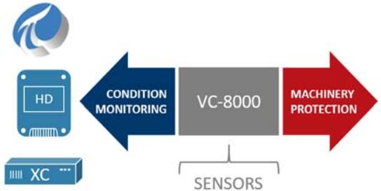
When VC-8000 racks will be used as machinery protection systems, the addition of condition monitoring functionality is completely self-contained within the rack. No additional connections are required. Simply order the rack’s monitoring modules with the CM-Enabled option. This is a firmware activated option in each monitoring module that streams the collected data to the System Access Module (SAM) in each VC-8000 rack. From there, the data is written to the on-board flight recorder (solid-state hard drive) inside the SAM and simultaneously made available at the CMS ethernet port on the SAM. When no connected server is present, the data is archived until the flight recorder fills (from 1-10 months or more), at which time the oldest data is overwritten. When a connected server is present, the same data written to the rack’s embedded flight recorder is streamed to the server. If a server connection is lost for any reason, the data is always redundantly available on the flight recorder, assuring that no data will be lost. When no connected server is present, the system operates in fully self-contained mode as CMSHD and the user manually retrieves data when desired - such as after a start-up, alarm event, or plant upset. When a connected server is present (with CMSXC or CMSPI), the data is streamed to the server where it is archived and made available over a network to any connected clients.
Condition Monitoring Only
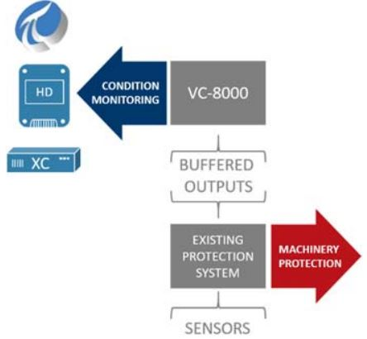
When a machinery protection system is already present, but no condition monitoring capabilities exist, its buffered outputs can be used as inputs to VC-8000 hardware, allowing condition monitoring to be easily retrofit to existing protection systems. From there, all three condition monitoring options are available: CMSPI, CMSXC, and CMSHD. Use of VC-8000 in this manner turns it into a data acquisition “front end” to access data from any existing protection system and stream it into PI, a connected external computer, or simply into the VC8000’s embedded flight recorder. By accessing data from the protection system’s buffered outputs, the condition monitoring hardware is non-intrusive and does not compromise the integrity of the underlying protection system. CM-only scenarios, for example, are frequently employed when the customer has a PI System, an existing protection system, and no condition monitoring. The VC-8000 forms a highly cybersecure “rich data gateway” between the protection system and the customer’s PI System. This scenario is also an ideal transitional step for machinery protection systems that will eventually be replaced, but which have no condition monitoring. Condition monitoring is added now via the VC-8000, and at a later date the VC-8000 is activated for machinery protection, replacing the underlying protection system entirely but without adding any additional hardware. The existing system is retired, and its sensors are moved to the VC-8000 inputs.

Proposal Terms
- Proposal validity: 60 days from the date of this proposal.
- Payment: Net thirty (30) days from date of invoice, subject to credit clearance.
- In addition to the terms of the offer listed here, Brüel & Kjær Vibro Terms and Conditions of sale will apply to all contracts unless Vendor specifically agrees to deviations in writing.
- Vendor offers a limited warranty of each of its Products and their parts against failure due to defects in material and workmanship or for failure of its Products and their parts to operate in accordance with Vendor-published specifications for a period ending thirty-six (36) months from the date of the invoice relating to the sale of the Product.
- Warranty and Terms and Conditions of Sale can be found at the following web address: https://www.bkvibro.com/en/downloads.html
- The address to reference on purchase orders is as follows:
For USD Currency:
BK Vibro America, Inc.
2243 Park Place, Suite A
Minden, NV 89423 USA
For Euro Currency:
Brüel & Kjær Vibro GmbH
Leydheckerstrasse 10
64293 Darmstadt, Germany
- Receipt and written acceptance of Purchase Order by Brüel & Kjær Vibro will be considered as the start of the project.
- Country or Origin or Manufacture: Components are procured from qualified world-wide vendors and are used to build, test, and ship final product from the United States of America.
- Shipment terms are Ex Works Minden, NV USA for supplied equipment.
- Average lead-time for delivery of hardware is approximately 10 weeks ARO (without custom cabinet(s)) or 14 – 16 weeks ARO (with custom cabinet(s)).
- Any aspects of the work scope or hardware supply not clearly stated in this proposal are not included in the quoted pricing.
- Phased Invoicing Terms are as follows:
  - No Site Services
Milestone | Milestone Description | Percent
Milestone 1 | Upon order placement | 30%
Milestone 2 | a. Upon approval of final BOM & design drawings (if no Cabinet) OR  b. Upon submission of internal test reports (if Cabinet FAT is not witnessed by Buyer or End User) OR  c. Upon completion of FAT (if Cabinet FAT is witnessed by Buyer or End User) | 30%
Milestone 3 | Upon dispatch/shipment of parts | 40%

  - Site Services:
Milestone | Milestone Description | Percent
Milestone 1 | Upon order placement | 30%
Milestone 2 | a. Upon approval of final BOM & design drawings (if no Cabinet) OR  b. Upon submission of internal test reports (if Cabinet FAT is not witnessed by Buyer or End User) OR  c. Upon completion of FAT (if Cabinet FAT is witnessed by Buyer or End User) | 30%
Milestone 3 | Upon dispatch/shipment of parts | 30%
Milestone 4 | Upon demobilization from on-site commissioning activities | 10%

General Cabinet Delivery Schedule
This proposal is based on the following schedule from receipt of order through Hardware shipment.
 | Number of Weeks ARO
Milestone Activity | 1 | 2 | 3 | 4 | 5 | 6 | 7 | 8 | 9 | 10 | 11 | 12 | 13 | 14 | 15
Submit Drawings (Electrical & Cabinet Designs)
Buyer Review Design Drawings
Incorporate Buyer Comments on Design Drawings
Design Freeze
Manufacturing
FAT
Hardware Shipment
Table 6

Exceptions and Clarifications
Vendor takes exception to Machine Monitoring System Specification in the following areas:
Section | Existing Wording | Suggested Wording | Notes
Table 7

Thank you for considering us for this project.

Best Regards,

Sales Name
Regional Manager
Sales Phone Number
sales.name@bkvibro.com
www.bkvibro.com

Attachment List
- Global Services Rate Sheet
Additional Documents can be found at the following location: https://www.bkvibro.com/en/downloads.html
- Terms and Conditions of Sale
- Warranty Policy
- API 670 Comments/Compliance
- SETPOINT MPS Datasheets/Manuals/Diagrams/Agency Approval Certificates
- SETPOINT CMS Datasheets/Manuals/Case History/App Notes

Trademarks used herein are the property of their respective owners (Metrix® Bently Nevada® and OSIsoft®). If a Buyer Logo is used on the title page, then the logo is owned by Buyer, and is not authorized by, sponsored by, or associated with the trademark owner.
Proprietary Information
Detailed technical scope, any design drawing packages, O&M manuals, other project specific information and pricing contained herein is confidential between Vendor and the Buyer for whom this quotation was prepared for. Any copying, distribution, discussion or use of this document for purposes other than its original intent; especially when a third party is involved, is expressly forbidden, without prior Brüel & Kjær Vibro GmbH (BK Vibro) written approval.

Prices are in US Dollar and do not include sales taxes or other regulatory fees
Prices assume purchase in 2019. If purchase is anticipated beyond 2019, please add 2.5% per year for escalation estimate.
Hazardous Area Approvals Marking and Ambient Temperature Range: 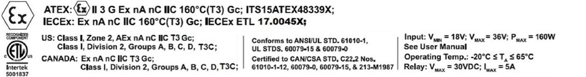
Vendor will invoice per the attached rate sheet if there are delays caused by Buyer or Others that are beyond the responsibility of Vendor
Workdays are defined as concurrent 10-hour days, no more than six (6) days per week.
Storage duration depends on hard drive capacity selected and number of channels in the VC-8000 rack. 1 month of storage is based on smallest available drive size and a fully populated 56- channel rack. Largest available drive size is 256GB and corresponds to 10 months of data storage for a similarly populated rack.
APHT = Amplitude / PHase versus Time. Available via standard trend plot capabilities.
Requires Compressor Controls Corporation TrainView™ server as data source; consult factory for details.
Export format is comma separated variable (.csv).
Requires supplementary PI DataLink software from OSIsoft, an Excel toolbar add-in, for PI Vision & ProcessBook.
An open data file format allowing users to export data, share with others, and view using the free CMS Display client.

